**Class Activity: Timer & Countdown Timer**

1. 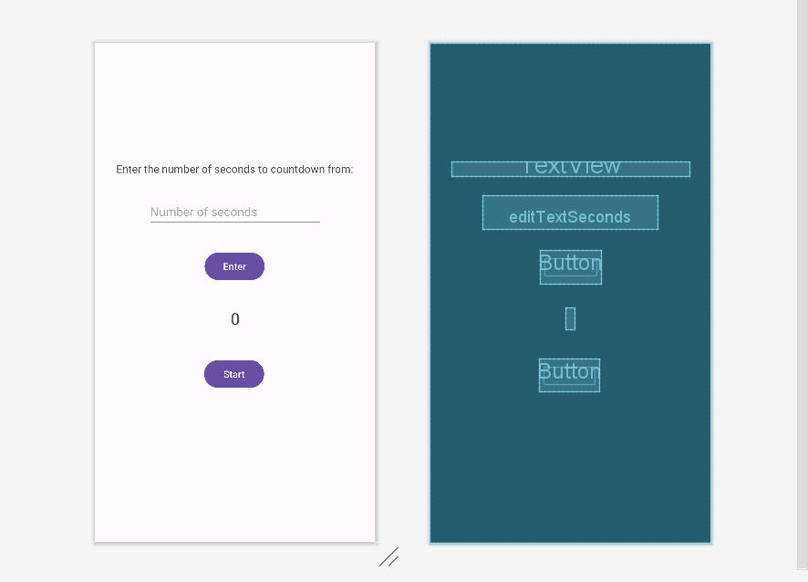3…2…1…Stop!

In this activity, we will be mainly focusing on using the CountDownTimer class. The goal is to create a custom countdown timer.

First, create a layout where the user can input the number of seconds with a “Enter” button. Then have the number of seconds to be displayed in a TextView and another button to start the countdown timer.

In the main activity, get the input of the number of seconds from the user and display the number of seconds. When the user clicks on the Start button, the timer will start counting down. When the timer finishes, display a short Toast message that the countdown is completed and reset the timer TextView to 0.

**Expected output:**

